Global Journal of Engineering Science and Researches
Paper Title (12pt Times New Roman, Bold, Center Aligned)
Correspondence Author^{*1} , Co-Author ²(11pt Times New Roman, Bold, Center Aligned)
^{*1,2}Designation, Department Collage, Country (11pt Times New Roman, Center)

ABSTRACT (11 Pts Times New Roman, Bold, Capital Letters, Center Aligned)
An abstract of no more than 200 words (10pt Times New Roman, Justified).

Keywords: 2-6 Keywords are required (10pt Times New Roman, Italic, Justified).

- INTRODUCTION(11 Pts Times New Roman, Bold, Capital Letters, Left Aligned)

All content should be written in English and should be in 2 column.
- Page type will be A4 with normal margin, word spacing should be 1.
- No space will be added before or after paragraph.
- This section should be typed in character size 10pt Times New Roman, Justified
- METHOD & MATERIAL(11 Pts Times New Roman, Bold, Capital Letters, Left Aligned)
Subheading
Subheading should be 10pt Times new Roman, justified.
This section should be typed in character size 10pt Times New Roman, Justified.
Figure:
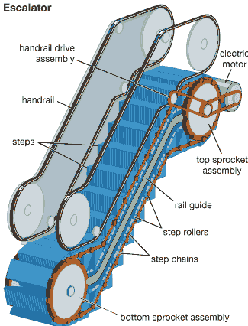
9pt Times New Roman, Bold, Italic

Sub-subheading
Sub-subheading should be 10pt Times new roman, Italic, Justified.

- OTHER SECTIONS (11 Pts Times New Roman, Bold, Capital Letters, Left Aligned)
This section should be typed in character size 10pt Times New Roman, Justified.

- RESULT & DISCUSSION(11 Pts Times New Roman, Bold, Capital Letters, Left Aligned)
The results and discussion may be combined into a common section or obtainable separately. They may also be broken into subsets with short, revealing captions.

This section should be typed in character size 10pt Times New Roman, Justified

Formulae:
R_{a}=R_{a}i_{a}+i_{a (1)}

R_{b}=R_{b}i_{a}+i_{b (2)}

R_{c}=R_{c}i_{c}+i_{c (3)}

Tables:

Table 9. Comparison table for motoring mode
 | PI | PID | FUZZY
SPEED(rpm) | 1500 | 1500 | 1500
Settling time of speed | 0.8 | 1.8 | 0.4
Speed fluctuations | ±20rpm | ±10rpm | -
Torque ripples | ±6 | ±0.5 | ±0.05

- CONCLUSION (11 Pts Times New Roman, Bold, Capital Letters, Left Aligned)
This fragment should obviously state the foremost conclusions of the exploration and give a coherent explanation of their significance and consequence.
This section should be typed in character size 10pt Times New Roman, Justified.

- ACKNOWLEDGEMENTS (11 Pts Times New Roman, Bold, Capital Letters, Left Aligned)
This section should be typed in character size 10pt Times New Roman, Justified.

REFERENCES (11 Pts Times New Roman, Bold, Italic, Capital Letters, Center Aligned)
- G. Bhalotia, A. Hulgeri, C. Nakhe, S. Chakrabarti, and S. Sudarshan, “Keyword Searching and Browsing in Databases using BANKS,” in Proceedings of the 18th International Conference on Data Engineering, ser. ICDE ’02, February 2002, pp. 431–440.
- V. Kacholia, S. Pandit, S. Chakrabarti, S. Sudarshan, R. Desai, and H. Karambelkar, “Bidirectional Expansion For Keyword Search on Graph Databases,” in Proceedings of the 31st International Conference on Very Large Data Bases, ser. VLDB ’05, August 2005, pp. 505–516.
- H. He, H. Wang, J. Yang, and P. S. Yu, “BLINKS: Ranked Keyword Searches on Graphs,” in Proceedings of the 2007 ACM SIGMOD International Conference on Management of Data, ser. SIGMOD ’07, June 2007, pp. 305–316.
- V. Hristidis and Y. Papakonstantinou, “DISCOVER: Keyword Search in Relational Databases,” in Proceedings of the 29th International Conference on Very Large Data Bases, ser. VLDB ’02. VLDB Endowment, August 2002, pp. 670–681.
- V. Hristidis, L. Gravano, and Y. Papakonstantinou, “Efficient IR-style Keyword Search over Relational Databases,” in Proceedings of the 29th International Conference on Very Large Data Bases, ser. VLDB ’03, September 2003, pp. 850–861.

